1. **Abstract**

The global energy system is transforming with the consideration of a growing population with rising living standards that will need more energy. Simultaneously, the world must find ways to reduce greenhouse gas emissions and provide sustainable energy production. As electricity is the fastest-growing part of the energy system and thus shifting to renewable energy production systems is the need of the hour. IEA reports that the Sun could be one of the largest resources for energy production for the upcoming ‘net zero goals’ of the world. Rapid decrease in the cost of installation and availability of solar radiation are major advantages for adoption, although this mode of generation of energy has a variable output which is influenced by several parameters. Hence solar energy forecasting is crucial to understand and predict the output of production, the demand of the consumers, and optimizing the dispatch of the electricity from grids to users. In this paper, we have analyzed innovative methodologies for forecasting solar energy radiation. Moreover, it provides a review and comparative analysis on various ANN, Probabilistic and Statistical, and Time Series based models used for estimating solar irradiation. Each of these models have been trained and tested in different geographical regions, weather conditions, and corresponding relevant parameters, which would provide an insight on efficient model selection and optimization for predicting short and long-term solar irradiation. Further, we have discussed some challenges while forecasting solar irradiation and future research direction in this domain.

Keywords: solar irradiation, solar energy, AI models, analysis, ANN, Statistical, Probabilistic, Time series, short and long-term forecasting

2. **Introduction**

Solar Panels are made of numerous semiconductor cells in an array, which when struck by photons from the Sun would knock electrons loose from their atoms. Conductors of electricity are provided at the sides of these cells which collect electrons and transfer them to wires. The solar inverter then converts DC electricity from solar modules to AC electricity, which is used by appliances. Excess electricity is then fed back to the grid. There are some alternatives to Photovoltaic solar energy generation, such as solar thermal systems, concentrated solar power, and passive solar gain.

A major concern around the solar energy production systems is the variability and unpredictability of environmental factors and other parameters it depends on. This poses issues with the grid reliability and expenses associated with operating the technical infrastructure. Moreover, peak demands and user consumption patterns are uncertain. Therefore, solar energy forecasting addresses this issue by developing models to predict the energy demand, production and irradiation from the Sun. Forecasting systems can help regulate PV systems and determine the dispatching of the energy created.

In this paper, we will particularly focus on Photovoltaic solar systems and the comparative analysis of methodologies used for forecasting solar irradiation. Below listed are the considered parameters for data collection and model training.

2.2 **Parameters**

* **Temperature(C)** - Temperature of the environment around the solar panels' installation. Temperature increase causes the bandgap of semiconductors to diminish, affecting its material properties. Moreover, the open-circuit voltage is the characteristic in a solar cell that is most impacted by temperature changes.
* **Humidity(mm)** - The amount of solar radiation is influenced by the atmosphere's relative humidity level since increased water vapor concentration produces an increase in reflected refractive radiation. The intensity of the solar radiation absorbed by the photovoltaic cell is lowered in this scenario, which is reflected in the cell's productivity.
* **Clear sky index** - Cloud cover affects the solar radiation reaching the solar panels, and this index estimates atmospheric attenuation due to clouds by measuring the ratio of surface solar radiation G to the solar radiation that would be received under a clear(cloudless) sky, Gcs.
* **Wind speed(m/s)** - There is an anticorrelation between wind speed and solar irradiation, and the wind speed range varies according to the geographical location and weather conditions.
* **The angle of incidence(ω)** - The solar incidence angle is the angle between the sun's rays and the normal on the horizontal surface.
* **Azimuth angle(φ)** - This is the angle between the projection of syn’s center onto the horizontal plane and due south direction.
* **Zenith angle(Z)** - This is the angle between the sun and the vertical.
* **Atmospheric pressure(atm)** - The pressure produced by the weight of air in the Earth's atmosphere is known as atmospheric pressure, and the weight of air is gravitational. This force increases as altitude decreases, exerting a stronger downward pull on the photons, raising solar intensity and the output current and voltage.
* **Albedo** - This is the amount of light reflected by a surface as is a crucial metric to determine the material of semiconductors in the solar panels. Moreover, the surroundings of the solar panels can diffuse solar radiation, and hence this effect can affect the performance of solar cells.
* **Solar insolence(kWh/m^2)** - Solar insolation is the measure of solar radiation incident upon a unit horizontal surface over a specified time for a given locality. It depends strongly on the solar zenith angle and also on the ratio of the actual distance to the mean distance of the Earth from the Sun. (S=solar constant, Zenith angle).
$$I=S*cosZ$$

* **Tilt angle(α)** - The angle of tilt of the solar panels is the tilt angle which is largely determined by the latitude values of the location of the solar panel.
* **Terrain Elevation(m)** - Higher altitudes plants with optimum conditions result in efficient solar energy production than at sea levels.
* **Solar irradiance(W/m^2)** - This is output power per unit area received from the Sun in the form of electromagnetic radiation in photons.
* **Global Horizontal Irradiance(W/m^2)** - GHI is the total amount of shortwave radiation received from above by a surface horizontal to the ground. This value includes the Direct Normal Irradiance (DNI) and Diffuse Horizontal Irradiance (DIF). DNI is solar radiation that comes perpendicular to the surface from the direction of the sun. DIF is solar radiation that does not arrive on a direct path from the sun but has been scattered by molecules and particles in the atmosphere.

$GHI=DNI*cosθ+DHI$ 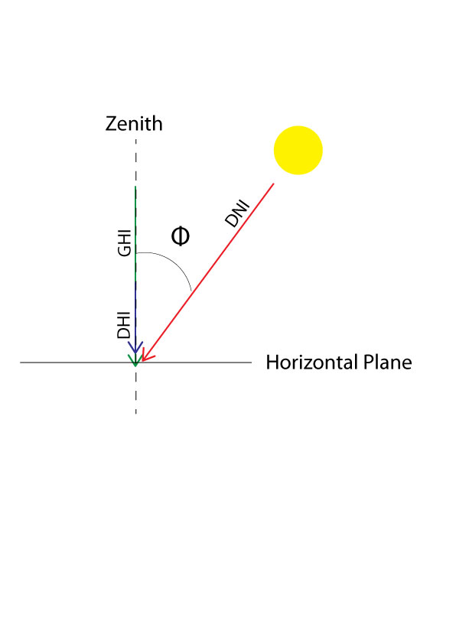

* Size of PV installation(kW) - These can be broadly categorized as small residential, medium and commercial, ground-mounted, and floating large-scale solar panel systems.

3. **Tables Introduction**

Bendali et.al.[9] studied the comparison of models with genetic algorithms by using the Time series data from the solar plants at Fes, Morocco for hourly forecasting of solar irradiation.

Ali-Ou-Salah et.al.[10] proposed a new hybrid model for predicting one hour-ahead global solar radiation in the city of Evora located south of Portugal. The weather data is collected from Evora city’s meteorological station using the Eppeley Pyranometer.

Alsharif et.al.[11] study aimed to develop a new model for forecasting solar irradiation whose data is obtained from the Korean Meteorological Administration over a span of daily and monthly average prediction output.

Liu et.al.[12] studied the short-term forecasting of solar irradiation and analyzed its uncertainties by using historical data from the PV power plant located in Ashland, US.

Ghimire et al. [13] proposed the design of a deep learning model from NASA’s GIOVANNI repository of the MODIS satellite and the land observed solar irradiation values were fetched from the Long Paddock SILO database that cover 4 of Australia’s solar cities to forecast long term solar irradiation.

Malvoni etal.[14] developed a hybrid Time series model for daily prediction of solar irradiation from the data acquired from PV systems from University of Salento, Italy.

Urrego-Ortiz et al.[15] worked on day-ahead forecasting of hourly solar irradiation with the data provided from SIATA station located in Medellin, Colombia.

Other Literature Review :

Ensemble approaches have been a key enhancement in terms of prediction accuracy and have grabbed the attention of many researchers. For example, AlKandari et al.[16] proposed an architecture of model wherein LSTM model and a statistical model such as the Theta model are trained separately on the same dataset and the results are combined to forecast the final forecast. Sometimes, ground data of solar radiation forecasting are not enough as they can be uncertain in some geographical regions, therefore an innovative approach was presented by Carrière, T.[17] where they address this limitation by combining data derived from satellite ,such as cloud motion vectors and clear sky index which is then estimated by adding Gaussian noises. Time series forecasting is a great method to model solar energy forecasting but existing methods fail to fully exploit latent spatial dependencies between pairs of variables in multivariate time series. But recent research proves that Graph Neural networks show a high capability to handle relational dependencies, for instance the study developed by Wu et al.[18] models the graph neural networks which automatically extracts the uni-directed relations and a novel mix-hop propagation layer and a dilated inception layer that are further proposed to capture the spatial and temporal dependencies within the time series.

**Challenges and Future Research Directions:**

Accurately predicting the solar irradiation involves uncertainties related to the characteristics of time series, optimization of ANN models and statistical hypothesis of the Probabilistic models and many weather conditions dependencies make these models highly volatile. Many factors are influenced by the geographical regions and seasons hence no particular model would be generalized. Although cloud imagery and hybrid models are paving the way for newer research models, emphasis on just improving accuracy is not adequate. Models that can optimize the input and relevant parameters without loss of precision could enable better performing forecasting in production. Further, the improvement in the solar cells technologies and materials have increased the efficiency of generation of solar energy, minimizing the loss of solar irradiation. As the residential modules of solar energy generation increase, forecasting their demand and solar irradiation methods could be challenging due to irregular patterns of use and varied environmental factors. While the forecasting of solar energy generation is important, so is the optimization of the electricity grid that stores surplus electricity produced by solar PV. Forecasting of solar grids demand and use could aid understanding usage patterns for the grid operators. Long term forecasting of solar irradiation is not yet significantly improved in terms of accuracy and precision due to high variance of climatic conditions and different parameters, while the short-term forecasting is observed to have a substantial development in research. In addition to these, parallel research is being conducted to determine the optimum tilt angle for monthly, seasonal, and yearly solar radiation relative to the site for obtaining the maximum number of photons from the sun. IOT sensors are being used to capture real-time data of the sites with large installation of PV, which aids in better analysis of conditions and predictive maintenance cycles of the cells. AI models have been a ‘black box’ , known for its lack of explainability and transparency especially for PV systems involving various parameters for forecasting. Here, XAI could be an emerging research field in the smart grid systems as it addresses this gap and helps understand why the AI system made a forecast decision.

Declarations

Author contribution statement

All authors listed have significantly contributed to the development and writing of this article.

Competing interest statement

The authors declare no conflict of interest.